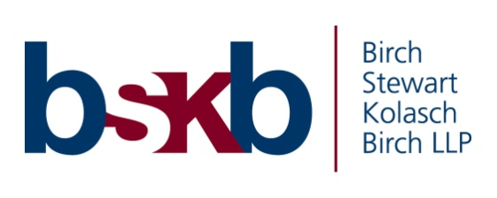

Michael T. Smith Named New Partner at Birch, Stewart, Kolasch & Birch

Birch, Stewart, Kolasch & Birch, LLP (BSKB), is pleased to announce the promotion of Michael T. Smith as a Partner.

Michael T. Smith joined BSKB in 2012 having practiced in the intellectual property field since 2001. Mr. Smith’s practice focuses on all aspects of trademark law, including clearance, prosecution, maintenance, enforcement, and licensing. His practice also includes patent prosecution, litigation in federal district courts, and inter partes matters before the Trademark Trial and Appeal Board as well as the Patent Trial and Appeal Board. Mr. Smith’s litigation experience includes the representation of clients from a variety of industries, including media, technology, hospitality and manufacturing.

Mr. Smith received his bachelor’s degree in biology from West Virginia University and his JD from the University of Akron School of Law.

Mr. Smith will continue to serve BSKB clients and their trademark, litigation, and patent matters.

